27 Church Road, Gatley, SK8 4NG
Email : Info@angelhomecareservice.co.uk

APPLICATION FORM

Before starting this Application Form, please read the following bullet points carefully. Please ensure that you complete
The application form in as full as possible since we cannot accept CVs. Please complete with black ink and block capitals
To make it clearer. This form will be kept confidential. Please note that no applicant will be unfairly discriminated
Against. This includes discrimination on account of age, cultural/religious/political beliefs, disability, ethnicity,
Gender, race, relationship status, sexual orientation, and/or Trade Union membership or stewardship. If you have any
Special requirements or support to complete this form (e.g., the need for large print or additional time) Please contact
The Registered Manager on 0161 511 2274 or 0748 3153235

Applicant Name: ___________________________ Date:_____________________

Position
Position applied for:
Preferred employment type (e.g. part time, full time):
Personal Details
Surname: | First name(s):
Current Address: | Postcode:
Telephone number (home): | Telephone number (mobile):
Email address:
Own Transport  Yes/No | How long has your license been held?
Details:
Are you a United Kingdom (UK), European Community (EC) or European Economic Area (EEA) National (please circle)?  YES / NO  If no, please detail current immigration status and the relevant visa currently held (including Visa number): | National Insurance Number:
Are you are related to a member of staff or Service User at Angel Homecare Service Ltd, please circle only:
YES / NO
Equality Act 2010
Under the Equality Act 2010 the definition of disability is if you have a physical or mental impairment that has a “substantial” and “long term adverse effect” on your ability to carry out normal day-to-day activities. Further information regarding the definition of disability can be found at: www.gov.uk/definition-of-disability-under-equality-act-2010.
For the purposes of this application and the interview stage only, is there anything you would like us to be aware of so that we can make reasonable adjustments during the process?
YES / NO / PREFER NOT TO DISCUSS

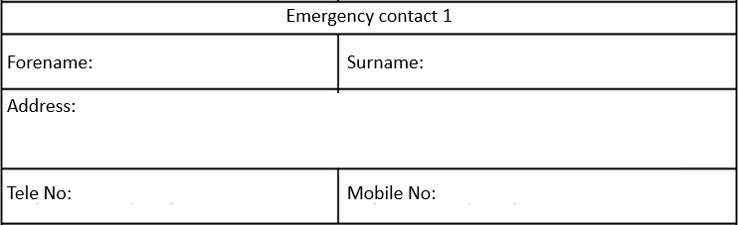

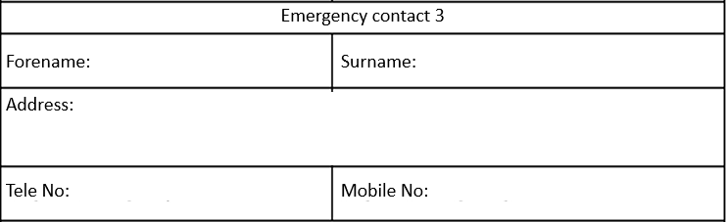

Education

School/College/University | Examinations Passed, Qualifications Gained and Year Obtained  (All qualifications will be subject to a satisfactory check).

Subject  (evidence of attending courses is required) | Location/Details | Date
Education and Training Courses Attended or Completing

Please record below the details of your full employment history beginning with your current or most recent first. Use a separate attached sheet if required; please sign the sheet(s).

Name and address of your most recent/last employer:
Start date and end date:
Nature of business
Position held and reason for leaving:
Salary / Rate:
Name and address of employer prior to the employer listed above:
Start date and end date:
Nature of business:
Position held and reason for leaving:
Salary / Rate:
Name and address of employer prior to the employer listed above:
Start date and end date:
Nature of business:
Position held and reason for leaving:
Salary / Rate:

Name and address of employer prior to the employer listed above:
Start date and end date:
Nature of business:
Position held and reason for leaving:
Salary / Rate:
Please detail here any gaps in employment and state why?

I have agreed to work two (2) weekend in a month according to the nature of the business.

YES NO

Reason

Supporting Statement

Please add here your reasons for applying. You should refer to the job description and person specification to guide you. It would also be of value to describe strengths and talents that set you apart from others as well as including skills gained from work, home, and other activities.

Referees
You must provide references from your two most recent employers. Please provide a character reference if you are unable to obtain two professional references, e.g. in the case of an applicant who has been raising children for ten years. All will be contacted, therefore please inform the referees of the fact that you have used their name. If you are unable to provide the required references, please discuss the matter with us.
Current or Most Recent Employer
Name:
Address:
Postcode:
Tel No and Email address:

Job title:
Previous Employer To The One Above
Name:
Address:
Postcode:
Tel No and Email address:

Job title:

Character Reference
Name:
Address:
Postcode:
Tel No and email address:
Relationship to you:

Safeguarding

Ex-Offenders Declaration

Please note this section will only be seen by those involved in the recruitment process and will be treated with the strictest of confidence.

Rehabilitation of Offenders Act 1974

Angel Homecare Service Ltd aims to promote equality of opportunity and is committed to treating all applicants fairly regardless of ethnicity, disability, age, gender or gender re-assignment, religion or belief, sexual orientation, pregnancy or maternity and marriage or civil partnership. Angel Homecare Service Ltd undertakes not to discriminate unfairly against applicants on the basis of a criminal conviction or other information declared.
Answering 'yes' to the question below will not necessarily prevent your employment. This will depend on the relevance of the information you provide in respect of the nature of the position and the particular circumstances.
Are you currently bound over or do you have any current UNSPENT convictions that have been issued by a Court or Court-Martial in the United Kingdom or in any other country?

YES NO
Do you have any current UNSPENT police cautions, reprimands or final warnings in the United Kingdom or in any other country?
YES NO

Privacy

Angel Homecare Service Ltd will only collect data for specified, explicit and legitimate use in relation to the recruitment process. By signing this application form, you consent to Angel Homecare Service Ltd holding the information contained within this application form. If successfully shortlisted, data will also include shortlisting scoring and interview records.
We would like to keep this data until the vacancy is filled. (We cannot estimate the exact time, but we will consider this period over when a candidate accepts our job offer for the position for which we are considering you). When that period is over, we will either delete your data or inform you that we would like to keep it in our database for future roles. We have privacy policies that you can request for further information. Please be assured that your data will be securely stored by the Registered Manager and only used for the purposes of recruiting for this vacant post. You have a right for your data to be forgotten, to rectify or access data, to restrict processing, to withdraw consent and to be kept informed about the processing of your data. If you would like to discuss this further or withdraw your consent at any time,
please contact the Registered Manager or Privacy Officer on 0161 946 8927, 0748 3153235.

Declaration

The information in this application form is true and complete. I agree that any deliberate omission, falsification, or misrepresentation in the application form will be grounds for rejecting this application or subsequent dismissal if employed by Angel Homecare Service Ltd. Where applicable, I consent that Angel Homecare Service Ltd can seek clarification regarding professional registration details.
Name: | Date:
Signature:

General Data Protection Regulations – Consent Form for Job Applicants

We are required to collect and hold data about all applicants to enable the company to process all job applications. GDPR places a further (and new) obligation on employers to inform all applicants, in more detail why we collect data, what we do with it, and how long we expect to retain it.
In order to process your application, we must obtain your informed consent about the data that we may hold about you.
We are not planning to transfer your data outside the EEA.
We are required to hold personal and special data (ethnic monitoring data) about you in order to process your employment application. The types of data, reason for holding the data and duration that the data is stored can be found below.
 | Type of data | Why we wish to hold it | How long it will be kept for
1 | Recruitment data  Previous employers  Types of job held at other companies.  Previous salaries  Skills and qualifications obtained.  Criminal record (delete as applicable) | This will allow us to make a decision on your suitability for employment/engagement. | Data obtained during recruitment will only be kept until either your application has been declined and then destroyed after 6 months.  if an offer of employment is made a more comprehensive GDPR data processing form will be issued
2 | Ethnic monitoring data  Data relating to your racial origin, religion, gender, sexual orientation, etc that are classed as protected characteristics under the Equality Act 2010 | We use this data to understand the ethnic make- up of our workforce and job applicants and it allows us to inform our recruitment process if we believe we do not have the correct diversity | This data will be kept for the duration of this round of applications and will be anonymised and stored for 4 years afterwards.

Agreement to use my data

I hereby freely give my prospective employer consent to use and process my personal data relating to my job application (examples of which are listed above).
In giving my consent:
I understand that I can ask to see this data to check its accuracy at any time via a subject access request (SAR).
I understand that I can ask for a copy of my personal data held about me at any time, and this request is free of charge.
I understand that I can request that data that is no longer required to be held, can be removed from my file and destroyed. In this instance I understand that I must provide details as to why I believe that the data being held is incorrect or being held unlawfully.
I understand that if I am unsuccessful with my application my data will be destroyed after 6 months.

Applicant Name (Print): ...…………………………………………………………

Signature: …...……………………………………………………….

Date: ……………………………………………………………

Office Use Only

Application Received Date:

Application accepted or Declined.

If declined reason:

Interview Date:

Interview Outcome:

Job offered: Yes or No.

Job start Date:

Signature and date:

